Final exam
AT74.08 Pattern Recognition and Image Processing
5 May 2016 (3 hours, 5 questions)
For all questions, please show your step-by-step solution and Matlab code. Please justify your answer and explain your code to get full-credits. No Internet access allowed.

Question 1: Please show 2D convolution, on the below data.

Data =
255 255 255
127 127 127
1 1 1

When the kernel is as shown below

Kernel =
1/9 1/9 1/9
1/9 1/9 1/9
1/9 1/9 1/9.

Note that the step-by-step calculation is required. If only the answer is given, you will get the maximum of only 5 points.
(20 points)

Question 2: Please show the open operation on the below data

Data =
1 0 1
1 0 1
1 0 1

When the kernel is as shown below

Kernel =
0 1 1
0 1 1
0 1 1.

Note that the step-by-step calculation is required. If only the answer is given, you will get the maximum of only 5 points.
(20 points)

Question 3: The license_plate2_blur is a blur image by the motion blur (no noise added). Please try to restore the original image as much as possible so that you can read the license plate as clear as possible. Please write down your Matlab code. (20 points)

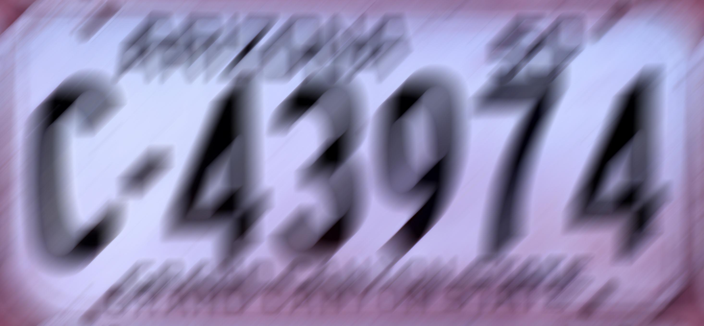

Question 4: You are asked to write a Matlab program to classify triangle, rectangle, pentagon, hexagon, heptagon, and octagon as shown in the picture below. What are the features that you should use? Please write the complete Matlab program for this classification. (20 points)

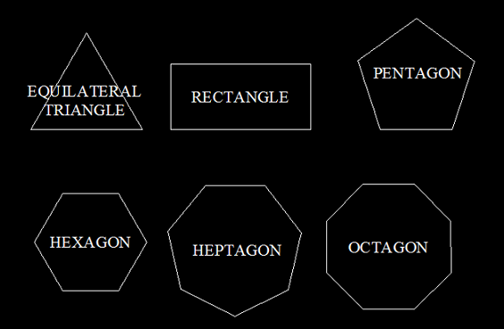

Question 5: Your friend told you that he has finished vehicle classification program. His program can classify 5 types of vehicle: sedan, motorcycle, van, truck, and bus. He has asked your help to calculate confusion matrix, precision, recall, and accuracy (F1 score) for each vehicle type, and total precision, recall, and accuracy (F1 score) for the entire system. After running 500 test images, you found out as follows:
The program can correctly classify sedan 80 times.
The program can correctly classify motorcycle 95 times.
The program can correctly classify van 70 times.
The program can correctly classify truck 75 times.
The program can correctly classify bus 60 times.
When there is a sedan image, the program classify it as a van 10 times.
When there is a sedan image, the program classify it as a truck 15 times.
When there is a motorcycle image, the program classify it as a sedan 10 times.
When there is a van image, the program classify it as a sedan 25 times
When there is a van image, the program classify it as a truck 10 times
When there is a truck image, the program classify it as a sedan 25 times
When there is a bus image, the program classify it as a truck 25 times
(20 points)

